EXPT. NO: 9 | TWO DIMENSIONAL ARRAYS
DATE:22.1.2020 | TWO DIMENSIONAL ARRAYS
Aim:
To write a C program for the following to
- Add two matrices
- Multiply two matrices
- Find the sum of diagonal elements of a matrix.
1. Addition of two matrices
Algorithm
- START
- Input Number of Rows And Columns
- for i=1 to rows
- for j=1 to columns
- Input matrix 1 [i][j]
- for i=1 to rows
- for j=1 to columns
- Input matrix 2 [i][j]
- for i=1 to rows
- for j=1 to columns
- matrix 3 [i][j]= matrix 1 [i][j] + matrix 2 [i][j];
- PRINT matrix 3
- STOP
Flowchart
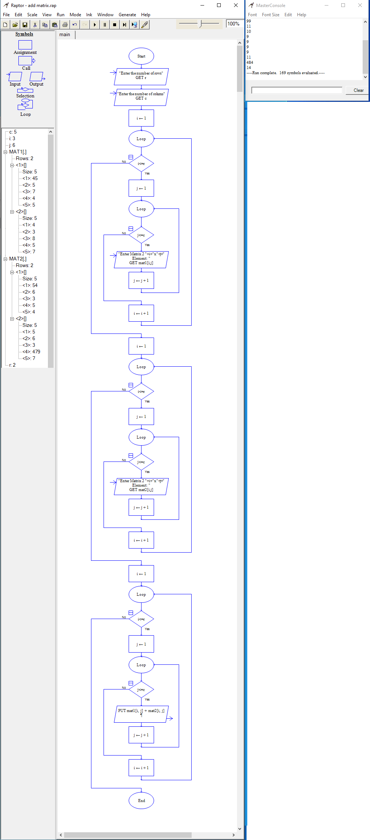
Program
#include <stdio.h>
int main(){
int r, c, mat1[100][100], mat2[100][100], sum[100][100], i, j;
printf("\nEnter the number of rows and columns : ");
scanf("%d %d", &r, &c);
printf("\nInput Matrix 1 elements : ");
for(i=0; i<r; ++i) {
for(j=0; j<c; ++j) {
scanf("%d",&mat1[i][j]);
}
}

printf("\nInput Matrix 2 elements : ");
for(i=0; i<r; ++i) {
for(j=0; j<c; ++j) {
scanf("%d", &mat2[i][j]);
}
}
printf("\nAdded Matrix\n");
for(i=0;i<r;++i) {
for(j=0;j<c;++j) {
sum[i][j]=mat1[i][j]+mat2[i][j];
printf("%d\t",sum[i][j]);
}
printf("\n");
}
return 0;
}
Output
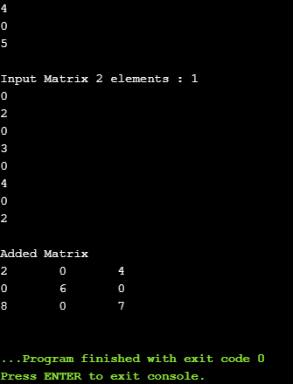
2. Multiplication of two matrices
Algorithm
- START
- Input Number of Rows And Columns
- for i=1 to rows
- for j=1 to columns
- Input matrix 1 [i][j]
- for i=1 to rows
- for j=1 to columns
- Input matrix 2 [i][j]
- for i=1 to rows
- for j=1 to columns
- Initialize sum = 0
- for k=1 to columns
- CALCULATE sum[i] [j] = sum[i][j] + mat1[i][k] * mat2[k][j];
- PRINT sum
- STOP

Flowchart
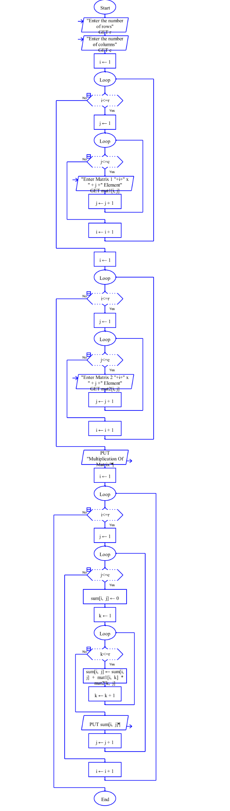
Program
#include <stdio.h>
int main(){
int r, c, mat1[100][100], mat2[100][100], sum[100][100], i, j;
printf("\nEnter the number of rows and columns : ");
scanf("%d %d", &r, &c);
printf("\nInput Matrix 1 elements : ");
for(i=0; i<r; ++i) {
for(j=0; j<c; ++j) {
scanf("%d",&mat1[i][j]);
}
}

printf("\nInput Matrix 2 elements : ");
for(i=0; i<r; ++i) {
for(j=0; j<c; ++j) {
scanf("%d", &mat2[i][j]);
}
}
printf("\nMultiplication of Matrix\n");
for(i=0;i<r;++i) {
for(j=0;j<c;++j) {
sum[i][j]=0;
for(int k=0;k<r;k++) {
sum[i][j] = sum[i][j] + mat1[i][k] * mat2[k][j];
}
printf("%d\t",sum[i][j]);
}
printf("\n");
}
return 0;
}
Output
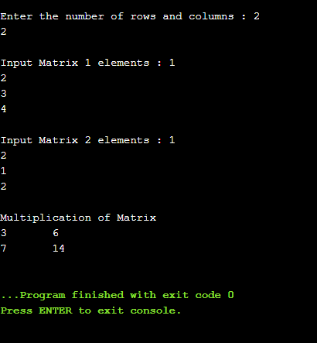
3. Sum of diagonal elements of a matrix
Algorithm
- START
- Input Number of Rows And Columns
- for i=1 to rows
- for j=1 to columns
- Input matrix[i][j]
- for i=1 to rows
- sum = sum + matrix[i][j]
- PRINT The Sum of Diagonal Elements of a Matrix = sum
- STOP

Flowchart
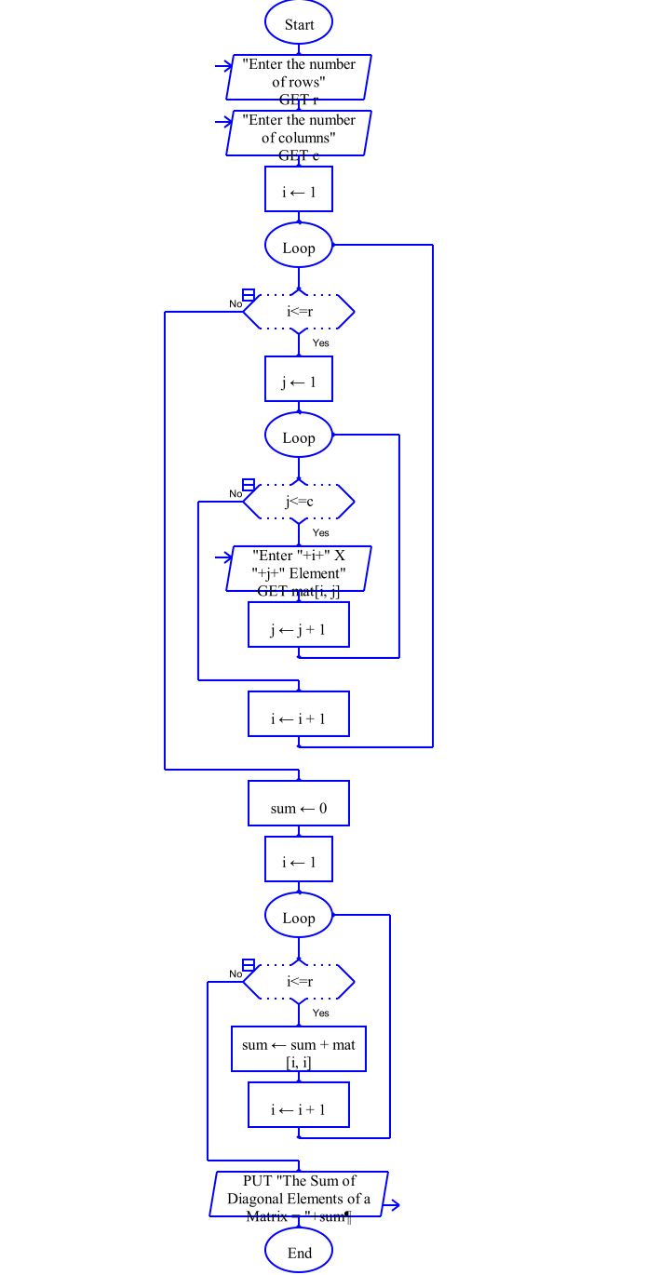
Program
#include <stdio.h>
int main(){
int r, c, mat[100][100], i, j, sum = 0;
printf("\nEnter the number of rows and columns : ");
scanf("%d %d", &r, &c);
printf("\nEnter The Matrix elements : ");
for(i=0; i<r; ++i) {
for(j=0; j<c; ++j) {
scanf("%d",&mat[i][j]);
}
}

for(i=0;i<r;++i) {
sum = sum + mat[i][i];
}

printf("\n The Sum of Diagonal Elements of a Matrix = %d", sum );
return 0;
}
Output
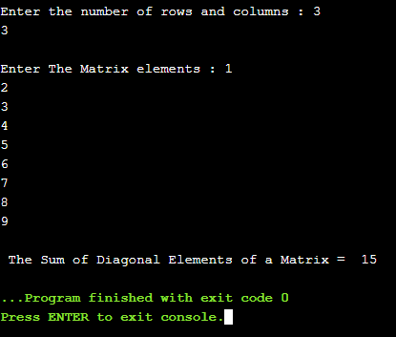

Result
Thus the C program was written and executed successfully for the following
- Add two matrices
- Multiply two matrices
- The sum of diagonal elements of a matrix

